Docker

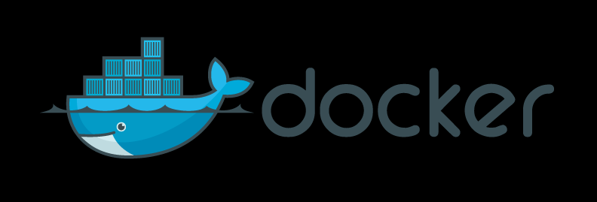
What is Docker?

Docker is a platform which enables you to run your applications in a container separately from the infrastructure to speed-fast the process of software development, shipping, and it’s delivery.

Docker Definition

Docker is a container running platform which was originally created on the Linux platform, but now supports other operating systems like Windows and Apple. The container consists of all the dependencies, and libraries necessary to support an application. The isolation between the software and its application doesn’t affect the development as Docker containers ensure uniformity between the development and the staging instance.

Understanding Docker

Docker splits the operating system into many containers for the applications to run, unlike virtual machines where one OS is divided into multiple OS. The heavyweight nature of conventional virtual machines makes it difficult to run many applications on it causing an issue of overloading. Docker resolves this issue by relying on the application than the infrastructure.

Docker is a command-line tool whose syntax is very simple. You just have to type docker run [OPTIONS] IMAGE [COMMAND] [ARG...] and it would then run the application you want in its own space.

How does Docker make working so easy?

Docker is used by most companies these days to get rid of the problems caused by traditional systems which are heavy and doesn’t posses the capabilities to carry more load. This often leads to downtime as application takes more than usual time to load time.

The self-contained space of Docker makes it an ideal tool to use as it is lightweight and it separates an application from it’s infrastructure, still maintaining the uniformity between the two.

One of the few reasons how Docker containers have made working easy is it’s ability to run apps and structure the code in a different way i.e., the apps are contained in a specific space. Now, for creating web-applications, a whole host of programs needed to be installed which often gets difficult after some point as loose our track of what has been installed. Also, when all the programs are installed in a server, it’s gets difficult to sell the website as now both the server, and the lease associated with it needs to be sold as the server hosts the entire web-application. Docker comes to rescue in this kind of scenarios as it allows to completely take the website inside a Docker container image. This image could then be deployed on any other servers and also it’s functionality could be duplicated. The Docker has a set of instructions to set up a server which helps to keep track of everything that is done and continue with building the application. All the dependencies, and the configuration files would be present in a self-contained space as long as the app is built with Docker.

Another important feature which makes working easy is it’s scalability. Docker uses micro-services i.e., the task is divided among different services. When an application grows, the challenge of scalability arises, and with Docker micro-service feature, each part of an application like caching, nodejs, and so on could be sub-divided into several services. The creation of separate spaces for different services in a Docker container separates it from the main program.

Additionally, the set of tools that Docker consists of allows you to deploy your applications across different clusters. You just need to specify rule or resources to each services in each of the containers. It ensures scalability and makes everything runs flawlessly.

The various subsets of Docker

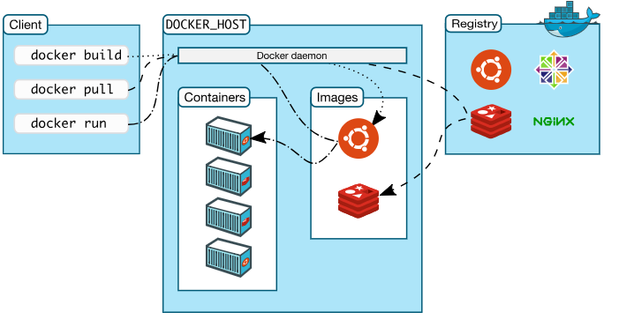
The above image is of the Docker architecture which uses a client-server topology. The Docker daemon is responsible for building, and distributing the Docker containers, and it interacts with the Docker client. Both client, and daemon could run on the same system or the client could be connected to the daemon via a remote system.

Let's look at each of the individual subsets of Docker and some of their attributes.

- Docker daemon: A Docker daemon interacts with other other daemons, and also manages containers such as images, networks, and so on.

- Docker client: The client is the primary mode of communication between the users and the Docker via the docker run command which is carried out by the dockerd.

- Docker registry: It is the Hub to store images and it could be accessed by anybody. The Docker Datacenter consists of Docker Trusted Registry. The docker pull command pulls the image from the configured registry, whereas the docker push command is used to push the image to the configured registry.

- Docker objects: Docker creates images, containers, and others objects during it’s usage.

Images: An image consists of instructions used to create a Docker container. It is
lightweight, fast, and Dockerfile is created to build our own image.

Containers: A container is an instance which is defined by an image. It could be isolated
from other containers, and operations like start, stop, delete, etc. could be performed on a container.

Top Docker Companies

Docker is an open-source tool which allows software developers to create applications on a container and deploy it on various platforms like Linux, Windows, and Mac.

Few of the top companies which uses Docker are:-

- The New York Times: It is an American newspaper based out of New York which was founded in the year 1951. The Newspaper uses Docker to produce content in crunch deadlines. The Docker container is used for the Interactive News department which differs from the traditional engineering team. Thus, with less engineering expertise involved, it was crucial to build a CD solution to ensure seamless production of contents. This resulted in the creation of a tool called Blade which was good, but lacked speed to achieve the ideal CI/CD workflow. Hence, they started using Docker containers to get the consistency across the different technologies.

- PayPal: PayPal is an American company which allows online money transfers as an alternative to the traditional checks method. The enormous number of transactions that PayPal processes per second has reduced the turnaround time due to it’s deployment in clouds and various architectures. Hence, it started using Docker containers which has increased it’s productivity by fifty percent. Also, it hosts around more than seven hundred applications to Docker which runs over two lacs containers.

- Business Insider: It is also an American news website which has operations worldwide in United Kingdom, India, Africa, China, France, Germany, and so on. It also uses Docker containers to speed-fast it’s news streaming system.

- Uber: Uber is a transportation company which is based out of California, USA. It also offers food delivery services, bike-sharing system, and others. Docker containers are the foundations on which the Uber infrastructure is relied upon. Recently, Uber developed Kraken, a P2P Docker registry to solve the performance issues which were there in the legacy Docker.

- Spotify: Spotify is an audio streaming platform which provides DRM-protected podcasts, and music from different media companies. The huge number of back-end applications in Spotify uses Docker image containers to run those services.

- Quora: Quora is a content sharing platform where people express their opinions on various topics or the questions asked. Due to it’s vast popularity and the volume of the contents shared, Quora uses a lightweight container like Docker to support the application and ensure negligible downtime.

- Ebay: Ebay is an American e-commerce website which facilitates C2C and B2C operations. To save milliseconds of load-time, eBay has started using Kubernetes, and Docker. It would enable dynamic caching abilities.

- Shopify: Shopify is a Canadian e-commerce online stores platform. Shopify uses Docker in their data-centres to ease it’s usability, and increase it’s adaptability.

- Yandex: Yandex is an internet-related products, and services corporation which is based out of Russia. It uses the lightweight Docker container on the Cocaine platform for app isolation, and infrastructure visualization.

- Groupon: Groupon is an e-commerce market based out of America, which provides activities, goods, and other services to almost fifteen countries.

What can you do with Docker?

- Docker helps to write code and share it with others which allows accessibility for all.
- Docker could also be used to execute test cases in a test-environment.
- In real-time, applications could be scaled up, and down based on the business with the help of Docker.
- Docker works best when more work is needed to be done with fewer resources.

Advantages of Docker

- Docker allows applications to be delivered in a fast, consistent manner.
- Docker’s portability allows applications to be deployed responsively and maintain it’s scalability.
- Docker’s lightweight nature helps to take more workloads in our computer and get better results.

Docker Scope

Industries always look for solutions which would speed-fast their applications, and save time. Docker or the virtual containers allows us to build applications on a reserved space separate from our infrastructure and thus reduces the problem with carrying a huge load.
Docker is the future, and several big companies use it in their systems as well. Mostly in the Data Science space, Docker has a massive scope as most companies don’t have the infrastructure to hold such voluminous data.
According to the latest LinkedIn search, there are almost 74,000 jobs available worldwide for people knowing Docker.
Why do we need Docker?

- Docker allows us to pack the application in an image which could then be deployed on different platforms.

- Applications are isolated from each other due to the containers maintaining a level for protection for the application.

Who is the right audience to learn Docker technologies?

Docker is useful for someone who is a web-developer or a Data Scientist.

The lightweight, fast, reliable Docker image containers allows one to host a web-server on a Docker image which would contain all the dependencies, and the configuration files of an application. The image could then be deployed, duplicated on different platforms. It reduced the hassle to install, and develop the application on a single machine and preventing it’s loading issue.

In case of a Data Scientist, Docker allows to store large amounts of data and perform the operations in a container which otherwise gets difficult to carry out in traditional systems because of it’s computational power. The ability of Docker containers to work with Big Data could also be used to run Apache Spark application in it.

How this technology will help you in career growth?

Companies, these days are moving out from the traditional systems, and consuming latest technologies to help their operations. Docker being the future, is a must to master for anybody who wants to be a Data Scientist, or a Web-Developer.

Starting from small-scale start-ups to big multinational companies, everyone uses Docker, and to be relevant in the market, you need to master the nitty-gritty of Docker.

Conclusion

Every now and then, new technologies and trends are developing, which is taking the world of digitization to the next level. Docker is the future of virtualization. Its simplicity and various usage make it a necessity in the modern generation.
Docker completed six years last month in which it has made some mind-blowing achievements including building software for NASA to deflect asteroids, the usage of gloo to join traditional apps.
Recently it announced the graduation of containerd, which builds container solutions. It has a dev to ops experience which addresses the need for Docker Enterprise and Kubernetes.
Every now and then, new technologies and trends are developing, which is taking the world of digitization to the next level. Docker is the future of virtualization. Its simplicity and various usage make it a necessity in the modern generation.
Docker completed six years last month in which it has made some mind-blowing achievements including building software for NASA to deflect asteroids, the usage of gloo to join traditional apps.
Recently it announced the graduation of containerd, which builds container solutions. It has a dev to ops experience which addresses the need for Docker Enterprise and Kubernetes.

The best way to learn Docker is through its official website - https://docs.docker.com/get-started/

